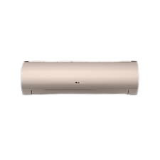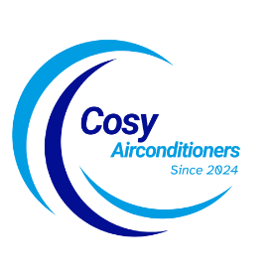

SKU: GSU-18HFCF/013USDC (W)

**Gree Viola Series Air Conditioner**

~~Rs 125,999.00~~ Rs 110,300.00

Low Voltage Startup

Copper Tube (Condenser & Evaporator)

Self diagnosis

With adoption of optimized cooling system, the cooling capacity of Haier Air Conditioners still could catch up 100% to provide the best cooling experience to user at 46◦C high temperature.

**Product details**

**THANK YOU!**

**WELLCOME TO OUR WEBSITE**